The Athletic Commons at GPS needs backpack organization because the backpacks cause safety issues, as well as creating a choke point which slows down everyone trying to use the athletic commons after school.
As a team we brainstormed solutions to the issue and how to create accessible storage units. We had around four ideas for storage throughout the area. At first we thought about using the tall pillars and put rounded storage cubbies surrounding the pillar. Another idea was to just use the same idea of storage cubbies but locate them under the windows near the pool or put hooks under the windows for larger bags.
One last idea we have was to create a triangular shape cubbies that seemed to be more sturdy, but not as practical. After creating some blueprint designs out of styrofoam, wood, and hot glue we settled on the cubie idea. It was easy to narrow this idea down since it would be easier to create a prototype. Each cubie will hold one backpack and it will be collapsible. This way students can enter the athletic commons, set their backpack in a cubby and exit. No more throwing bags on the ground everywhere causing a tripping hazard, now the floor can be clear of bags.
Our final solution is a cubie 16in x 20in x 16in with an opening in the front to slide backpacks in. The product is set on tracks so it can be collapsable and movable if needed. The materials we used are plexiglass, from COVID shields (see fig 1), different types of glue, and 3D printed hinges. Our design requirements was for the storage to be out of the way/ collapsible, quickly accessible, able to hold 50+ backpacks, affordable, and easy to fix. Keeping these requirements in mind we were able to make a final design solution. This includes a box-like structure with an opening in the front. The hinges and track are collapsable and easy to transport if needed. After creating our prototype we will work with GPS staff to create multiple boxes from the recycled plexiglass. Then we will stack the cubbies up in empty spaces like the windows in front of the pool. The final solution includes getting 4 pieces of plexiglass cut into 16in x 20in x 16in squares. Then 4 smaller pieces cut into long rectangles to make tracks to slide the plexiglass in and out. Using a 3D printer up to four hinges are made for each cubby. Then insert the backpack in through the front of the cubby and stack as many cubbies on top of each other as needed. The supply list includes plexiglass, 3D printer, Acrylic glue, and marker for measurements and accuracy.
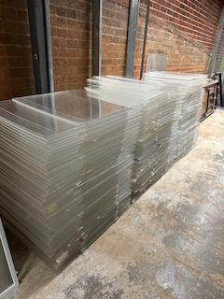
Figure 1
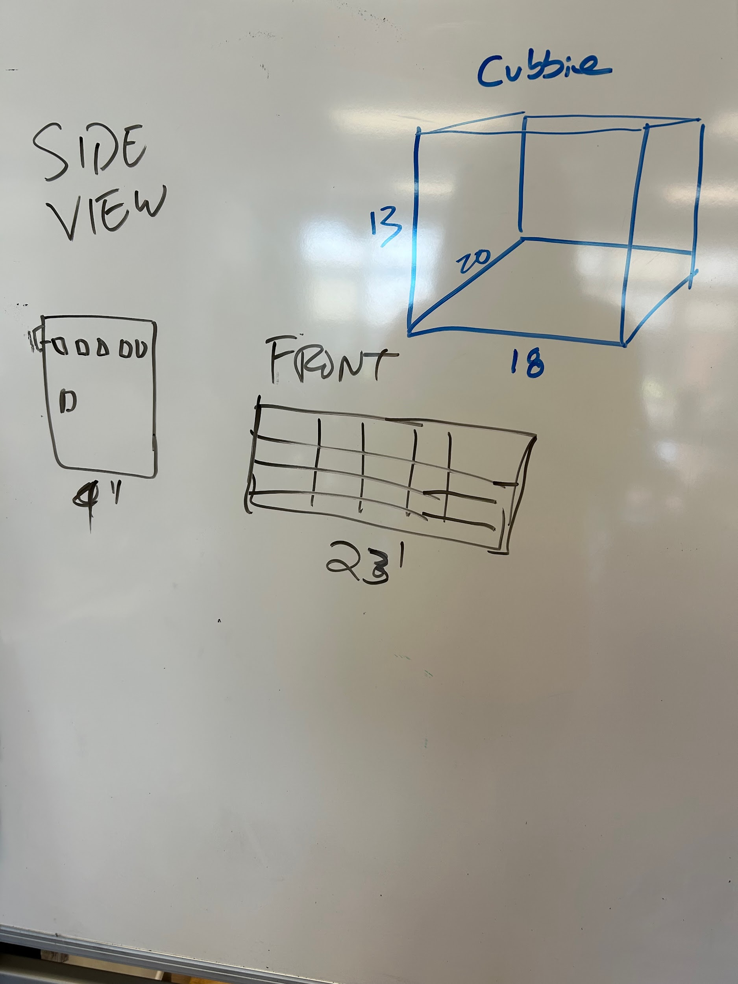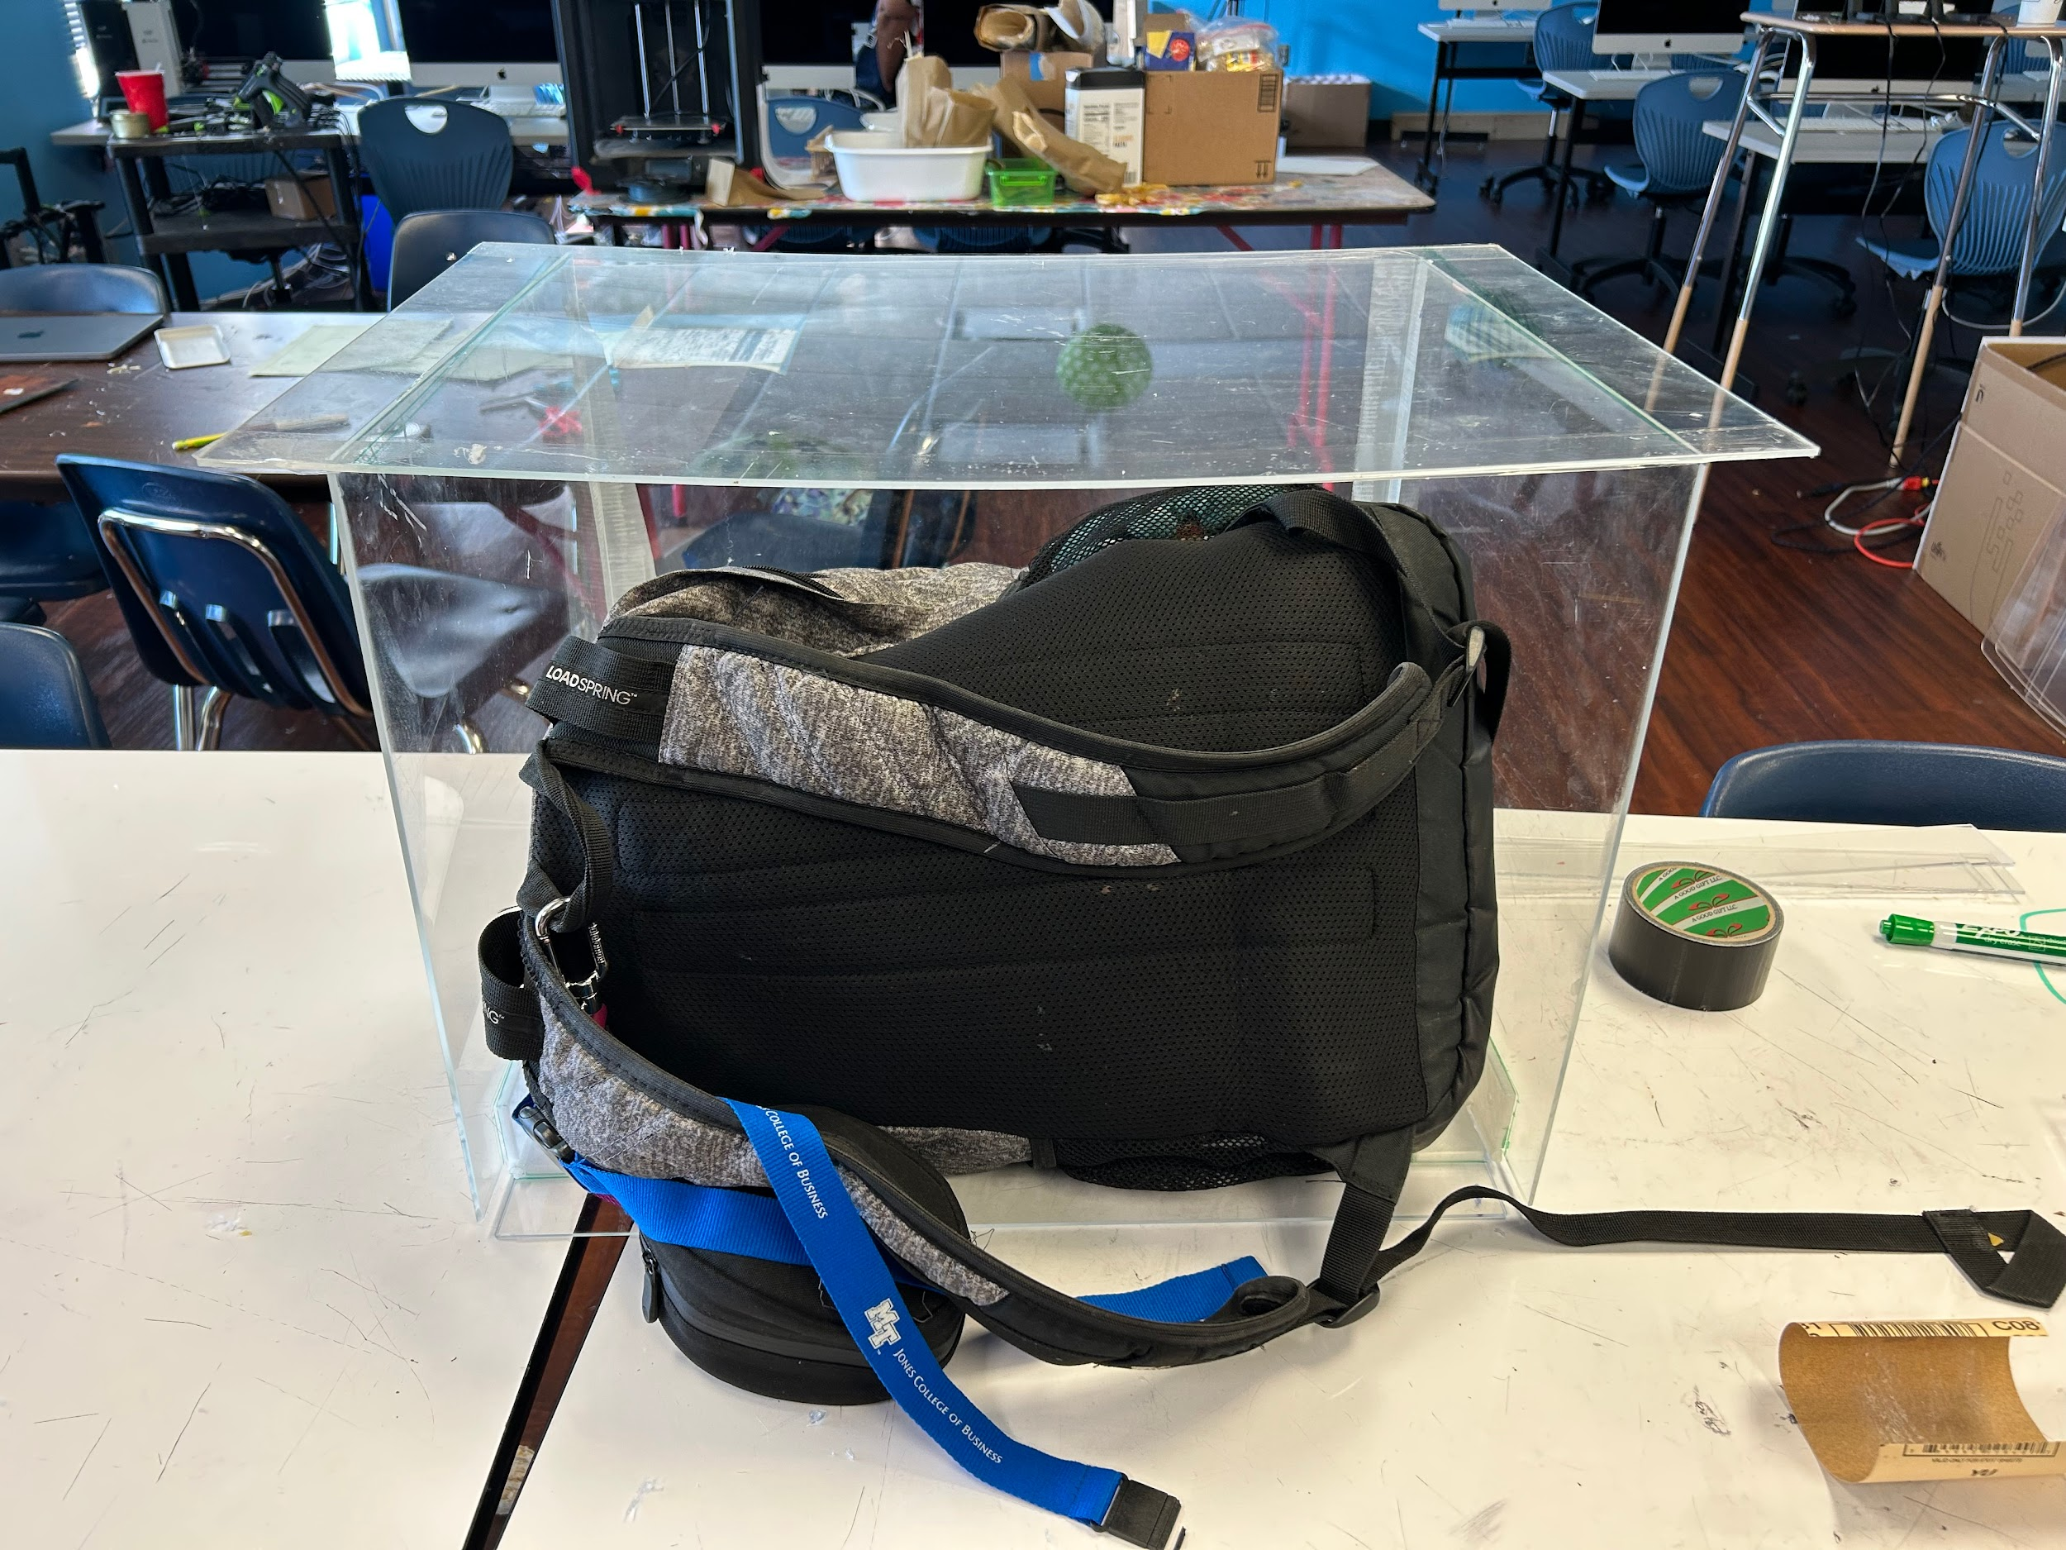
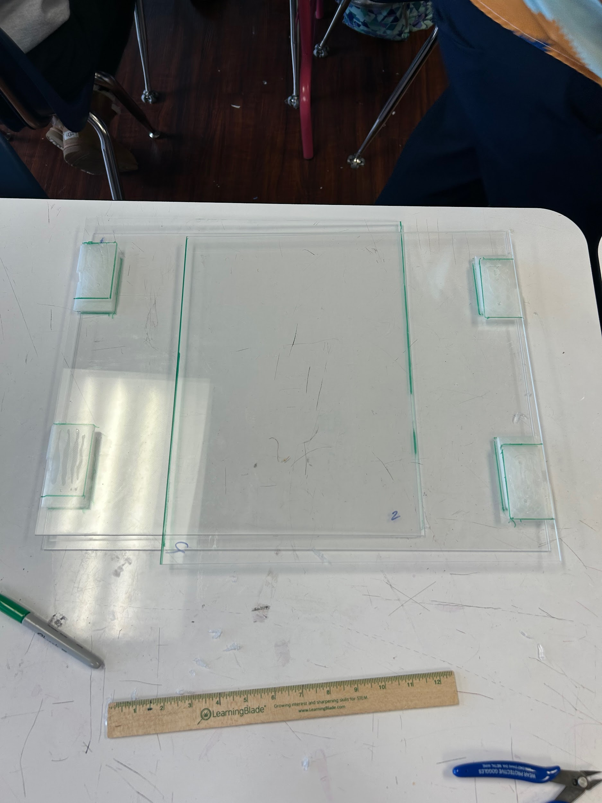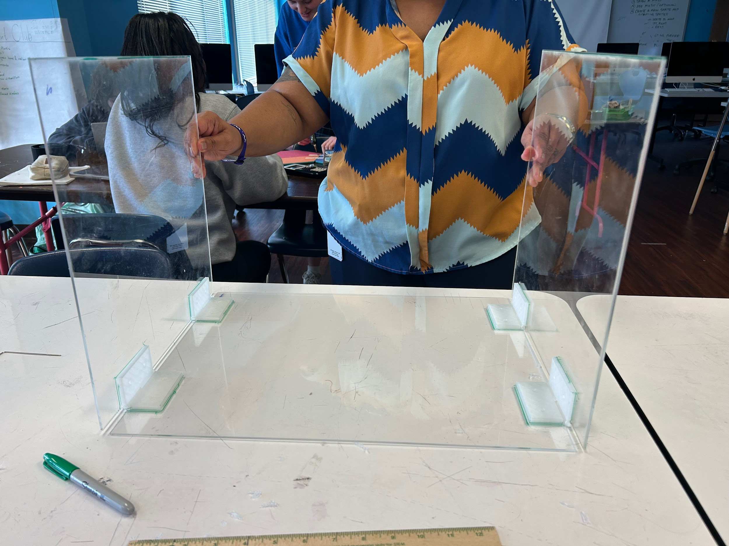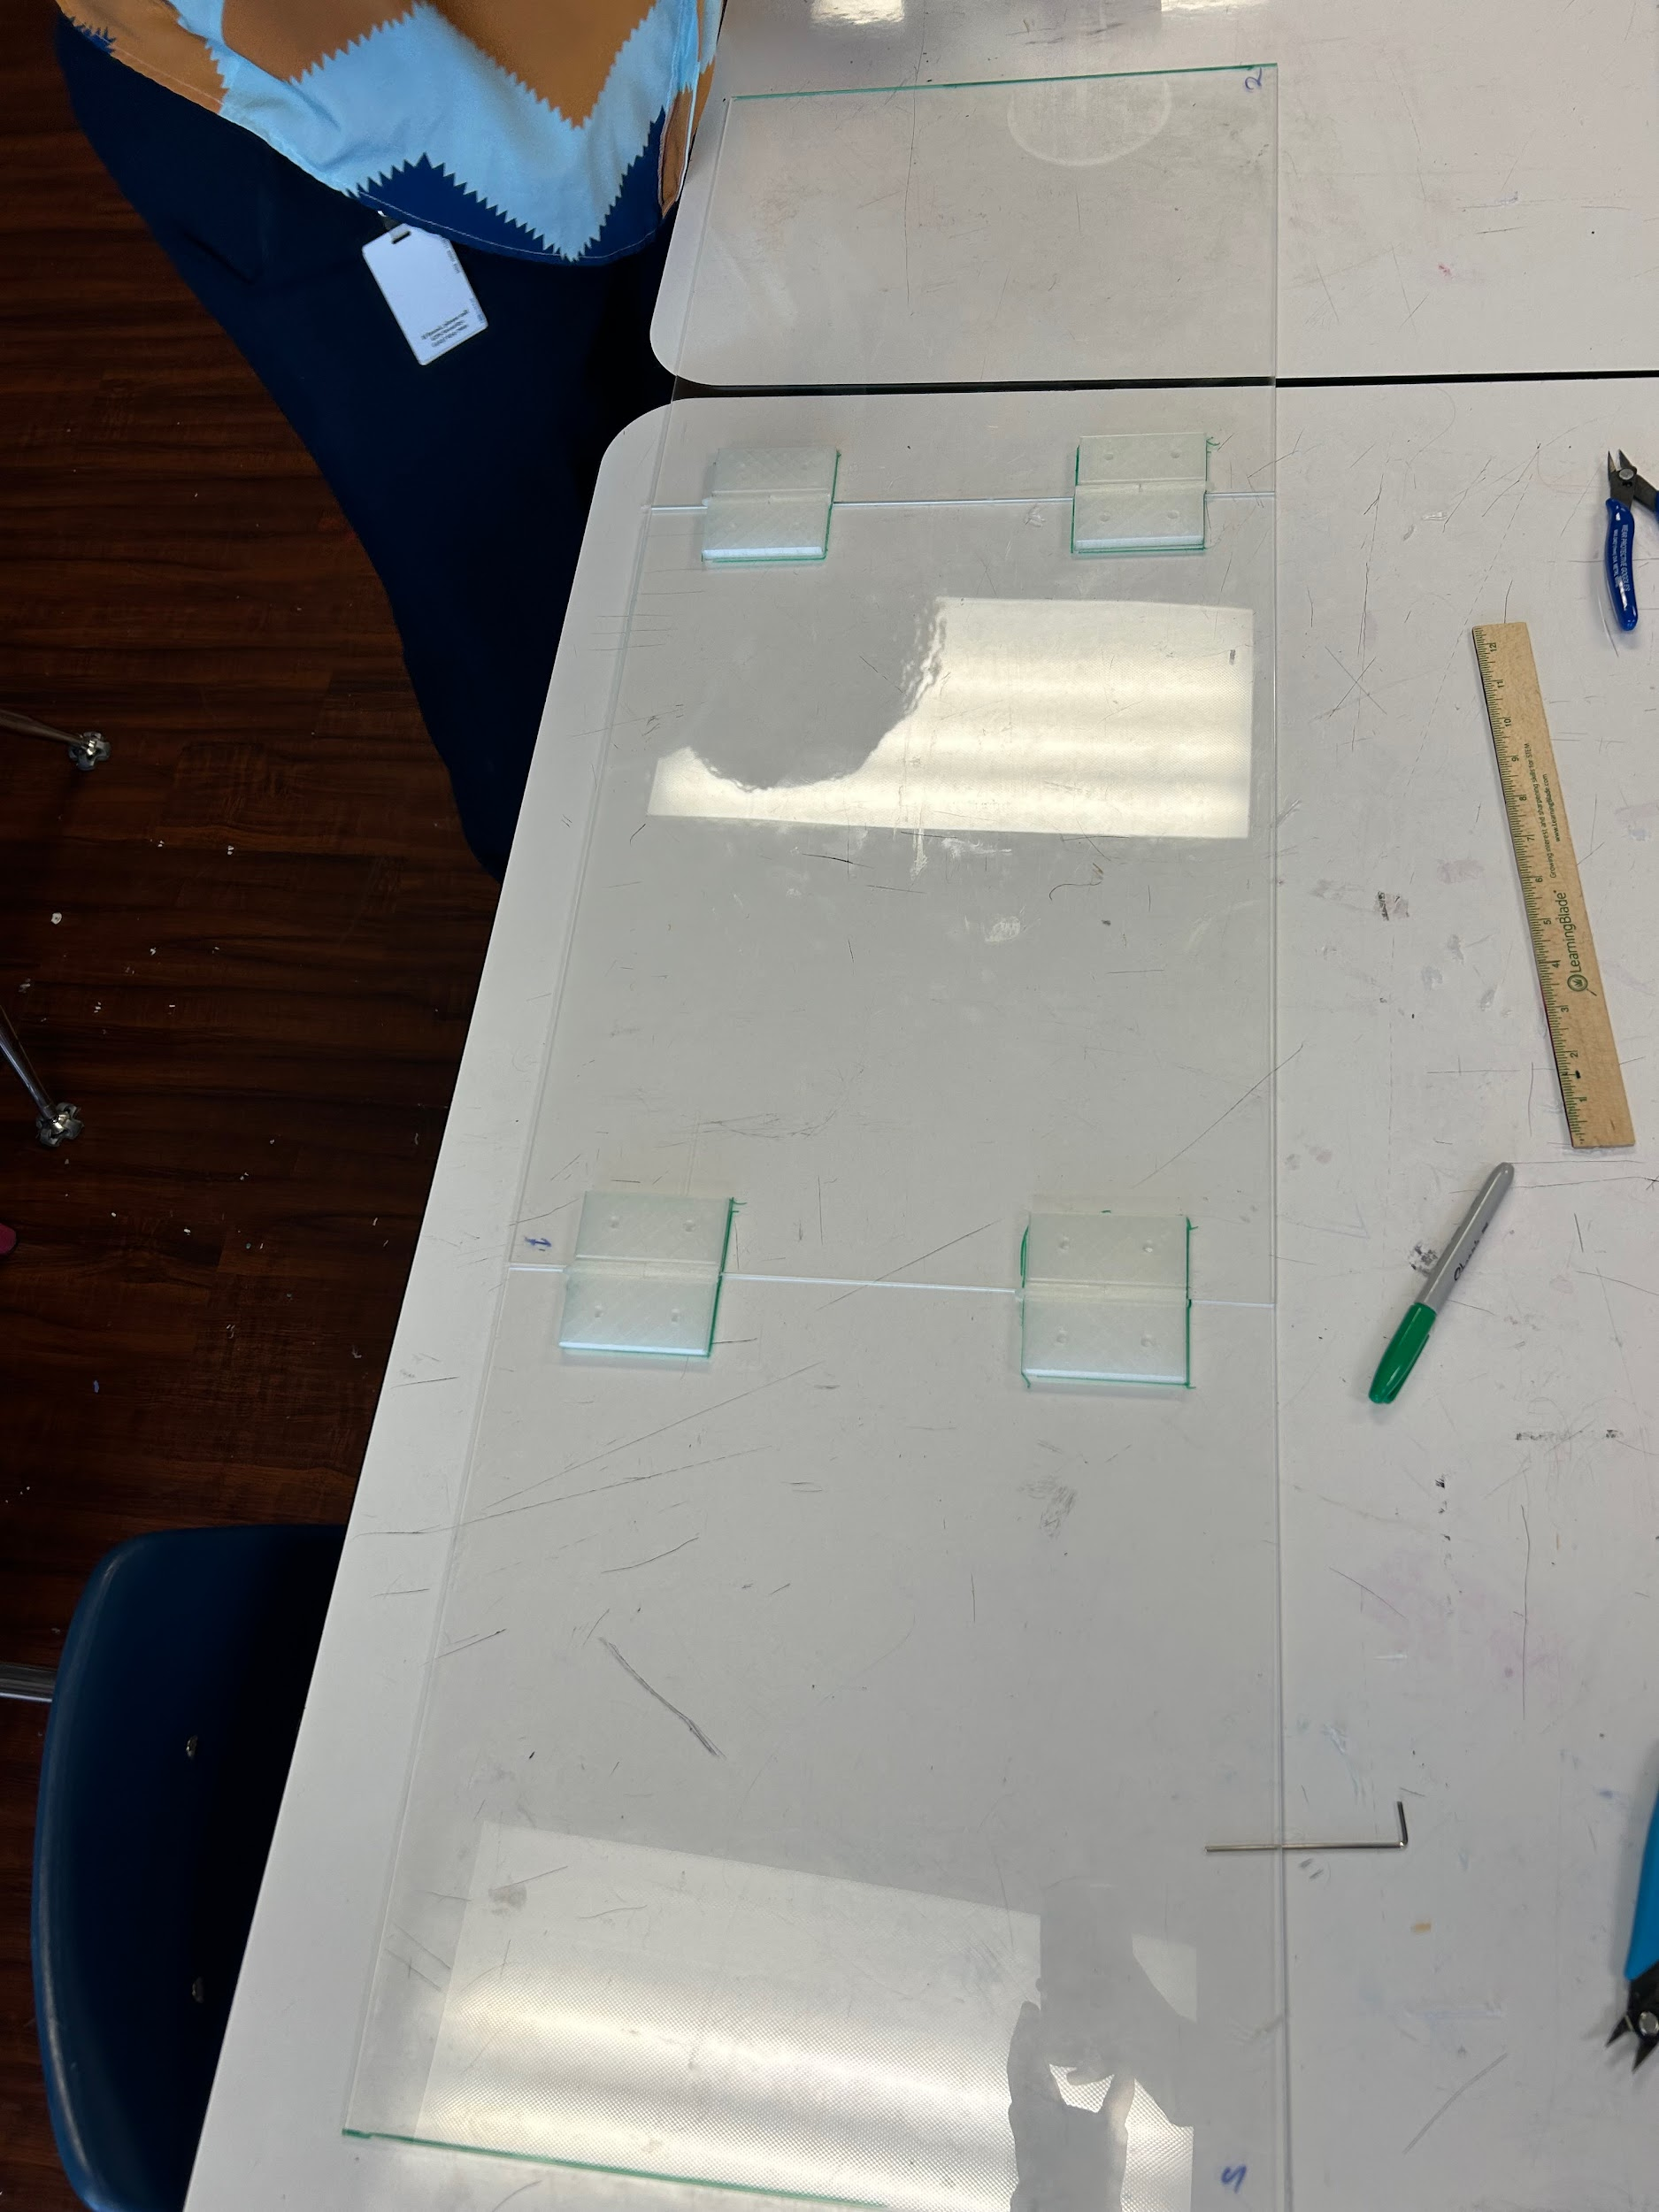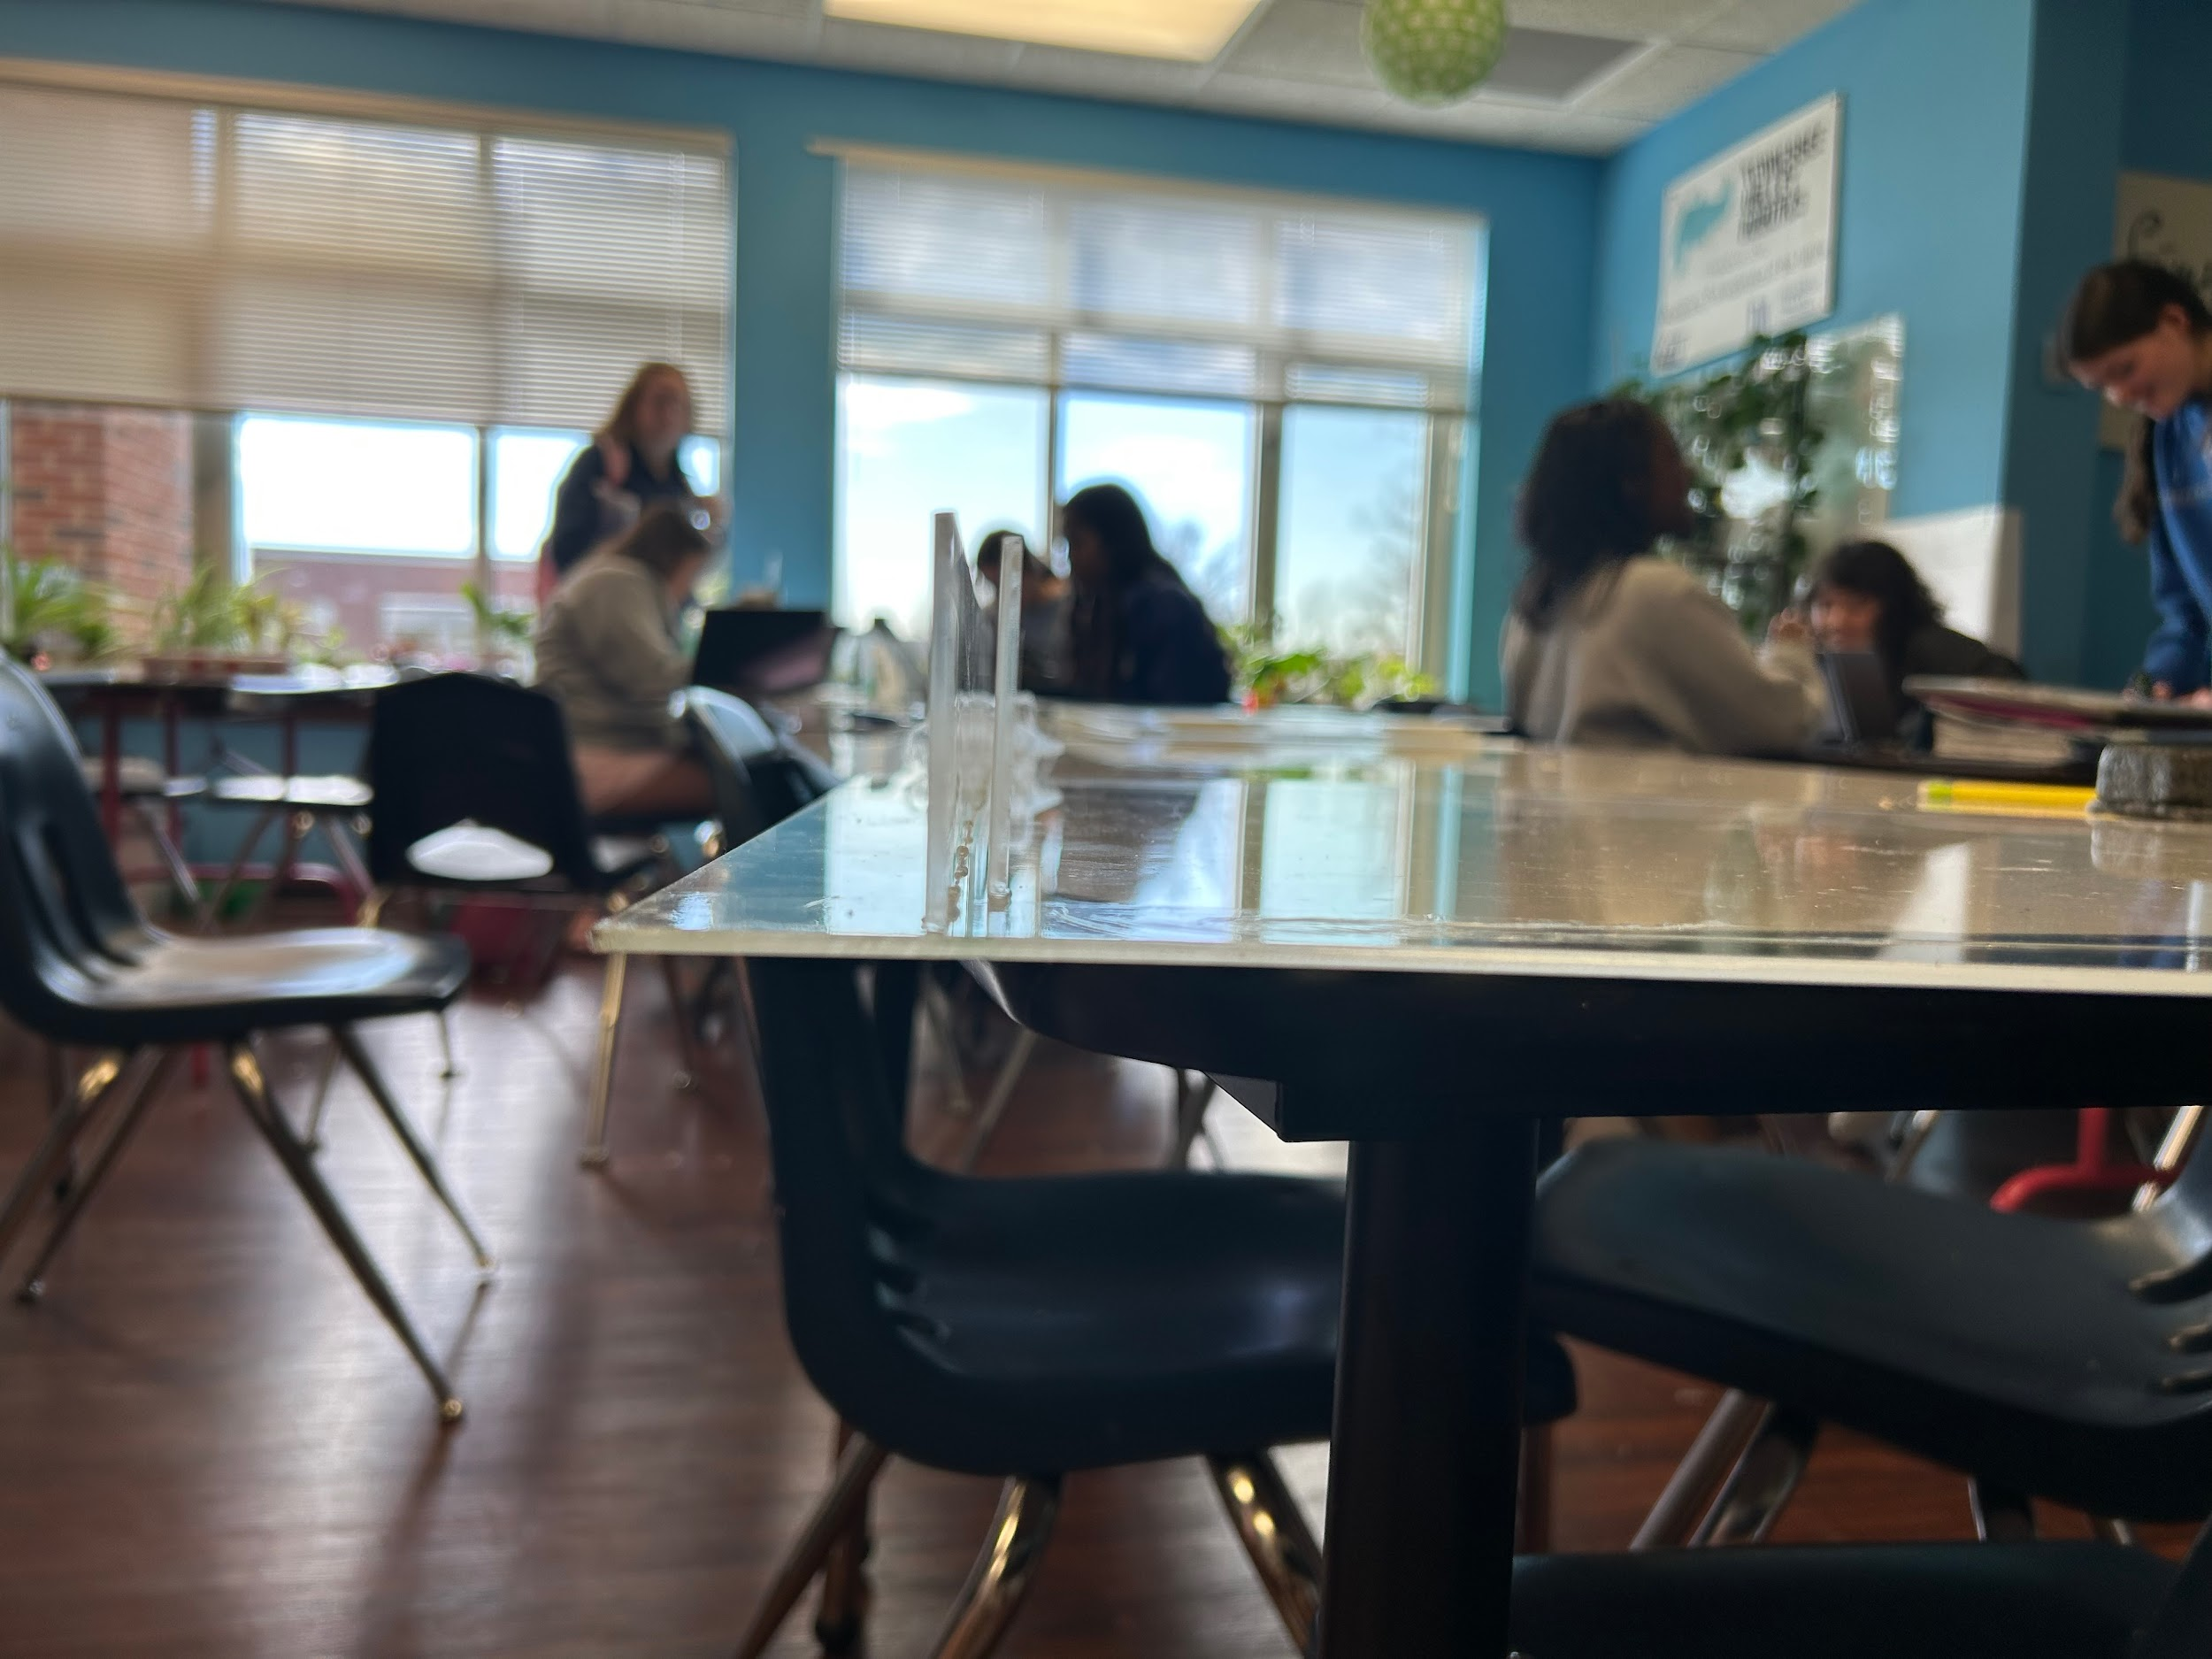
Design Idea #1
Date: 12/4/24
Description: Cubbies surrounding pillars and other places in Athletic Commons
Drawing that includes distinguishing information such as scale, dimensions, and materials:
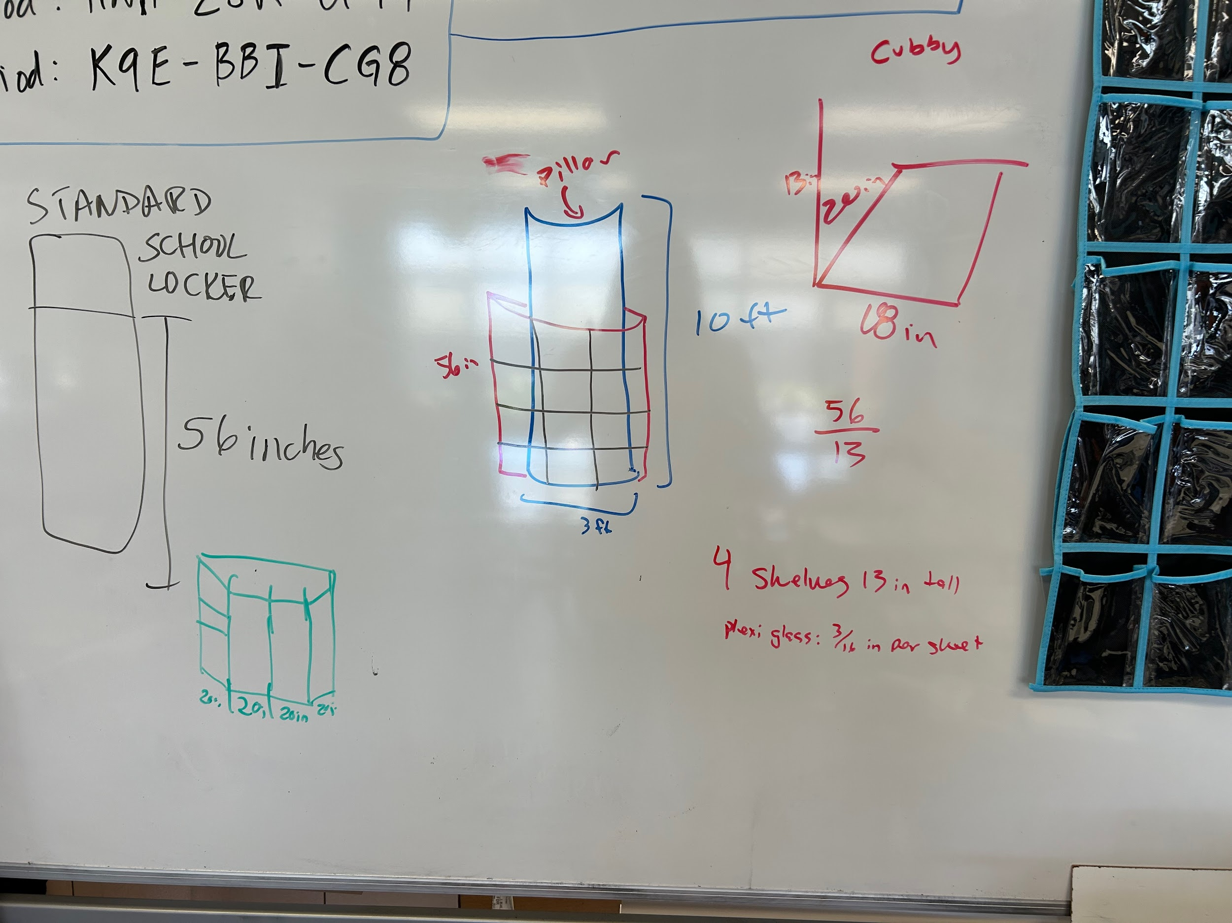
Design Idea #2
Date: 12/4/24
Description: Benches Have cubbies underneath them by pool
Drawing that includes distinguishing information such as scale, dimensions, and materials:

Design Idea #3
Date: 1/09/25
Description: set spaces for each grade
Drawing that includes distinguishing information such as scale, dimensions, and materials:
Design Idea #4
Date: 1/09/25
Description: Hooks under and on the the window frames
Drawing that includes distinguishing information such as scale, dimensions, and materials:

Design Idea Comparison and Selection (D1, D2)

Options | Req.1 | 35% | Req.2 | 30% | Req.3 | 20% | Req.4 | 15% | Total Score
Option 1 | 9 | 3.2 | 7 | 2.1 | 8 | 1.6 | 9.5 | 1.425 | 8.3
Option 2 | 10 | 3.5 | 8 | 2.4 | 7 | 1.4 | 8.5 | 1.275 | 8.6
Option 3 | 3 | 1.1 | 5 | 1.5 | 9 | 1.8 | 10 | 1.5 | 5.9
Option 4 | 10 | 3.5 | 5 | 1.5 | 7 | 1.4 | 6 | 0.9 | 7.3

Design Blueprint (D4)
Describe all of your design's details such that someone unfamiliar with your project could build your prototype. Include sketches, dimensions, CAD (if taught in your class), manufacturing methods, material choices, supply lists, and costs.
Design Blueprint #1
Date: 1/30
Sketch:
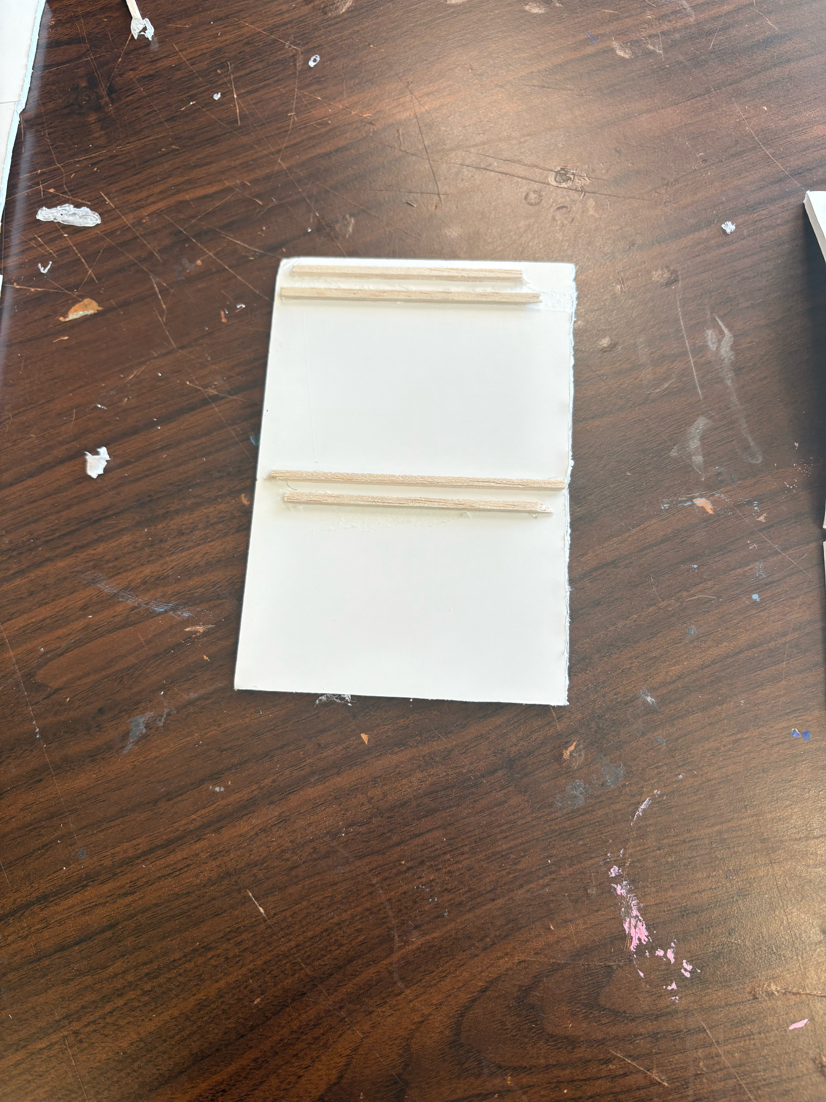Element A
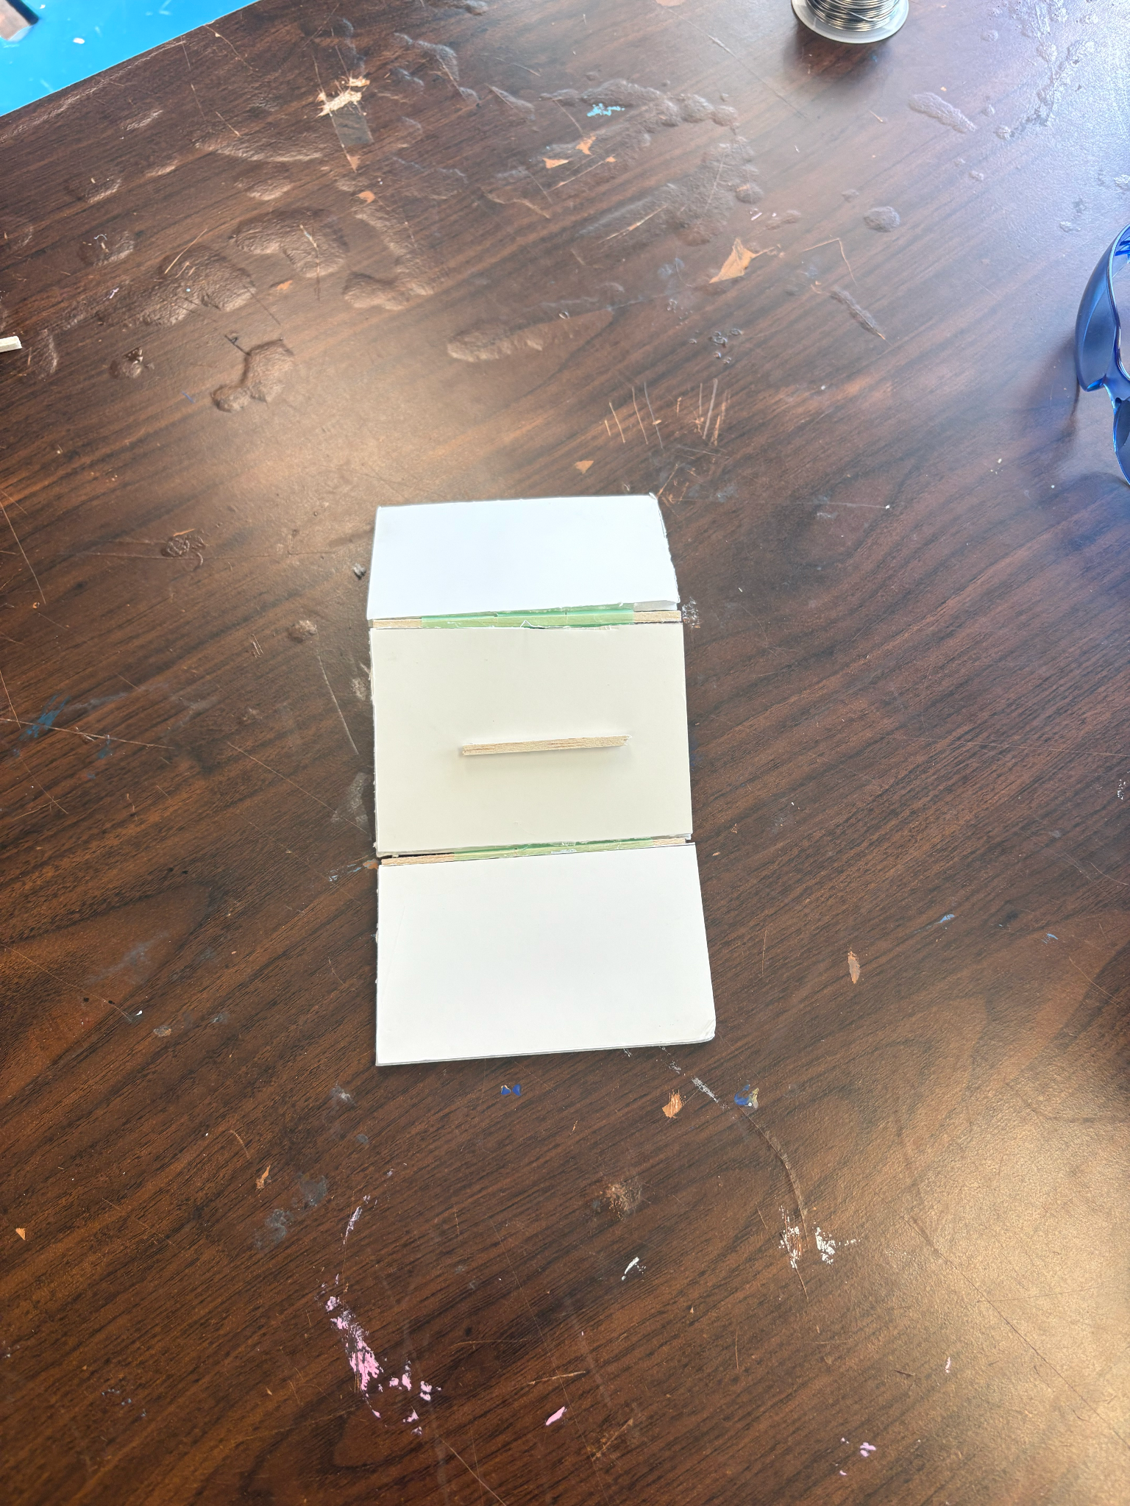 Element B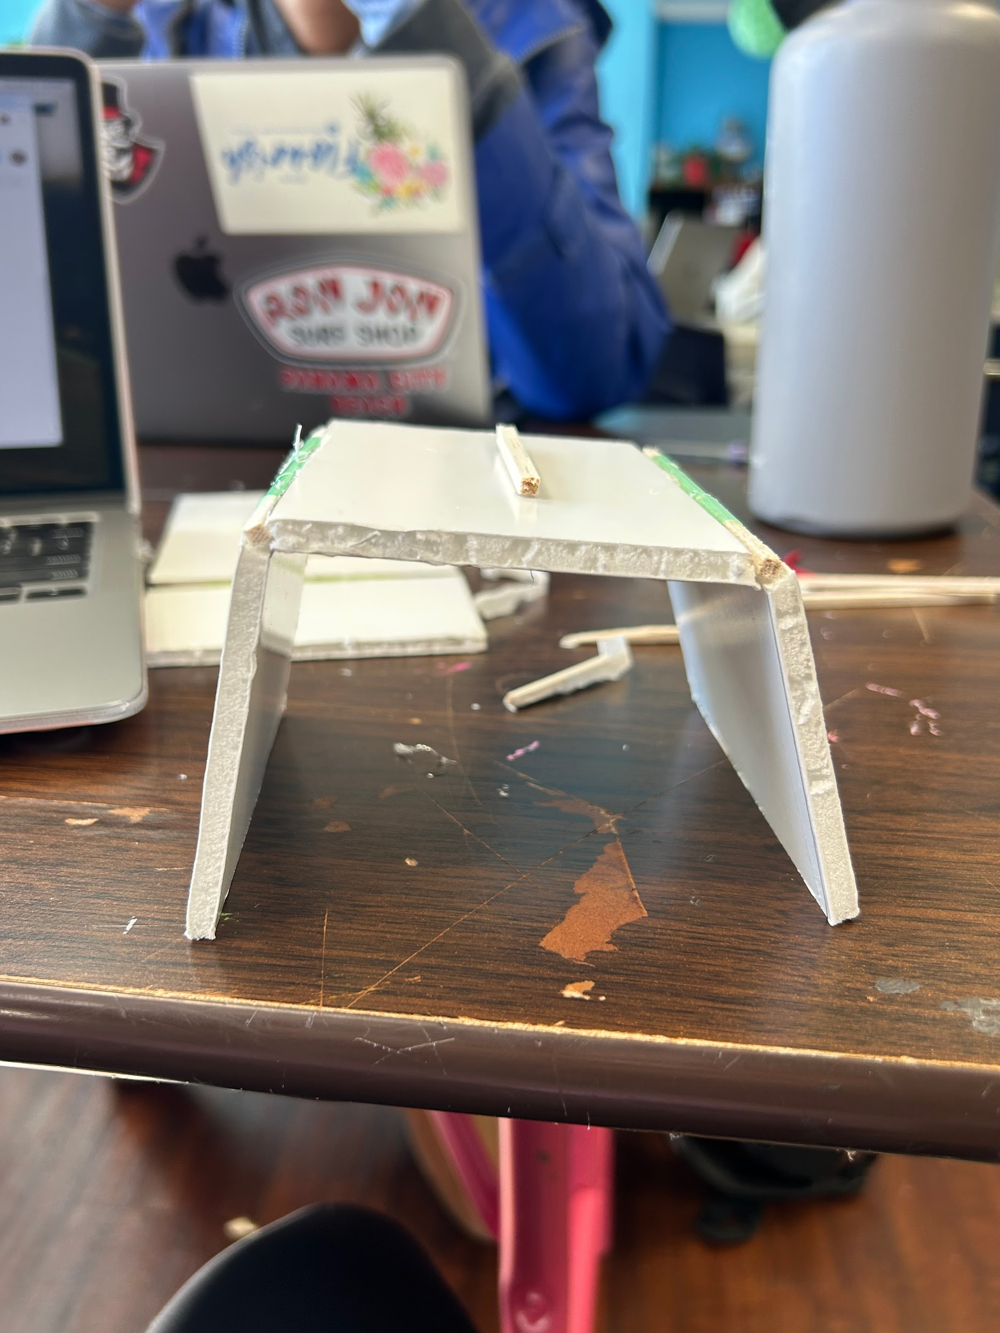
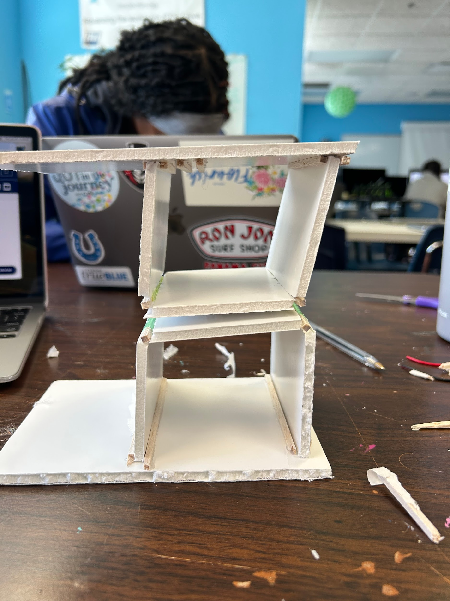Element C
2/21
Due to our laser cutter not being able to cut our original dimensions we took 4 inches off every side of the plexi glass. New dimensions: 16x14x9

2/24
Instructions for backpack: must go into the cubby bottom first with handle sticking out
The 16x14 base is to small for a backpack so the base is being changed to 20x16 and the walls are now 16x16
Manufacturing Methods:
Step 1:
Step 2:
Step 3:
Supply List and Costs:
Item | Cost each | # needed | Total
Plexiglass | Already have
3d printed hinges | Already have
Total Cost

*

Plan of Action (D3)
A Gantt chart is encouraged to lay out the primary steps expected on a visual timeline. Larger tasks from the Gantt chart should be broken down further into detailed sub-tasks, which may be housed in a different day-to-day document. Discrete tasks should include enough detail such that others could replicate the efforts, such as procedures, materials, tools, status, etc.

